1.App registration in Azure Active directory:

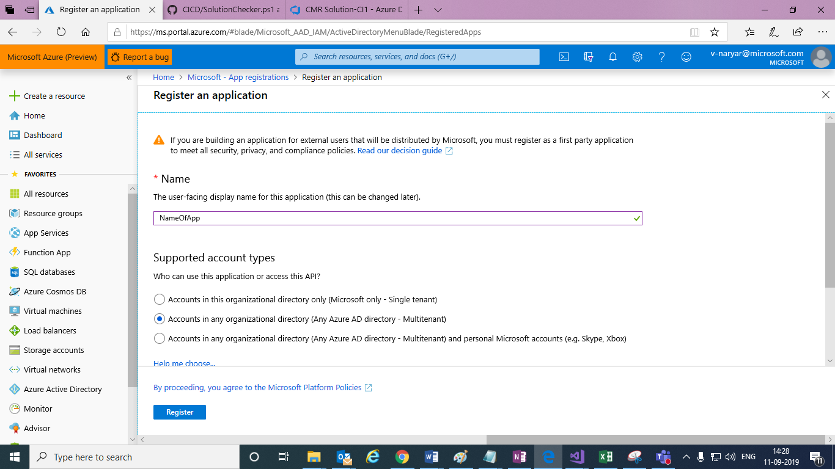

Give Name and selection Account type and click on register button and App will be created .

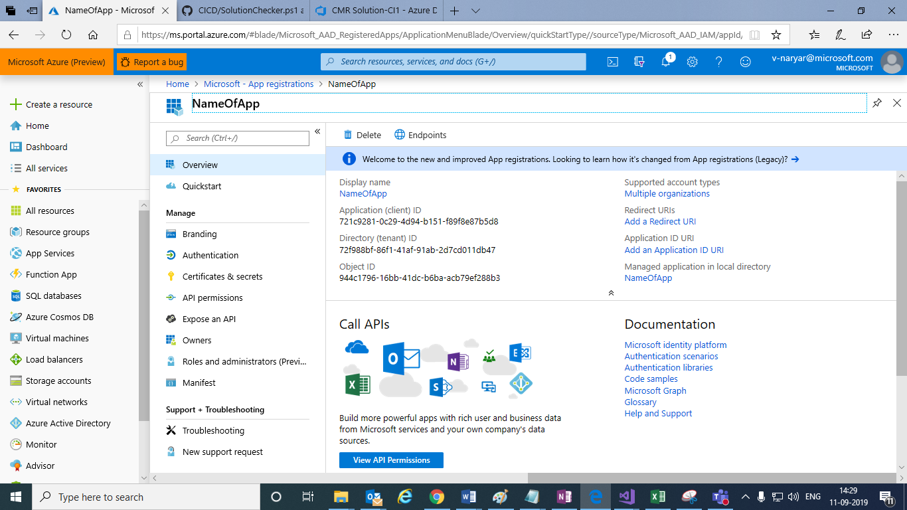

Copy client ID and Tenant Id from above screen.

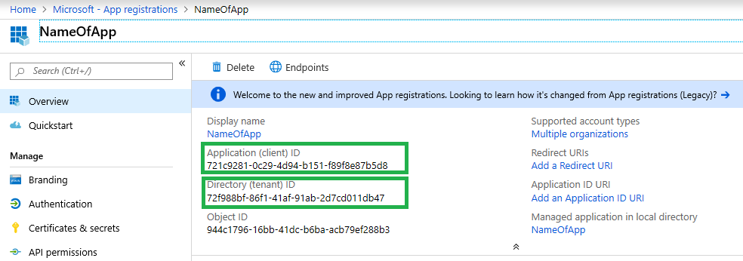

Click on Certificates and secretes in the application blade,

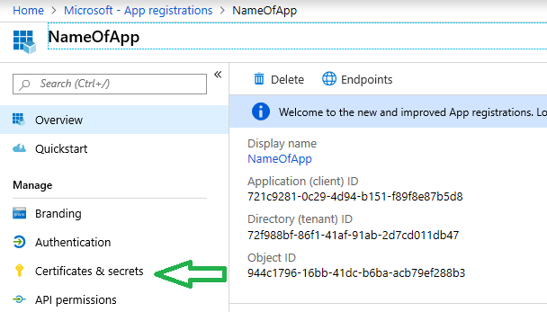

And

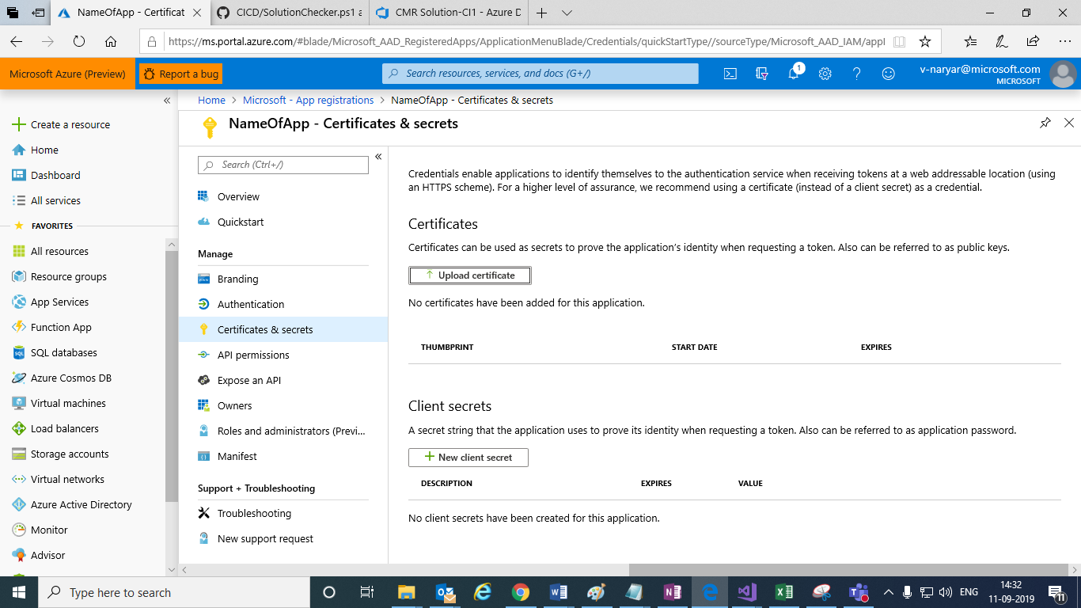

Click on **+ new client secret** button ,

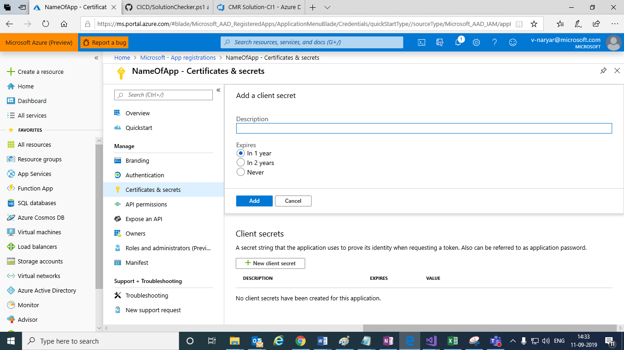

Give description and click on Add button and app secret is created .

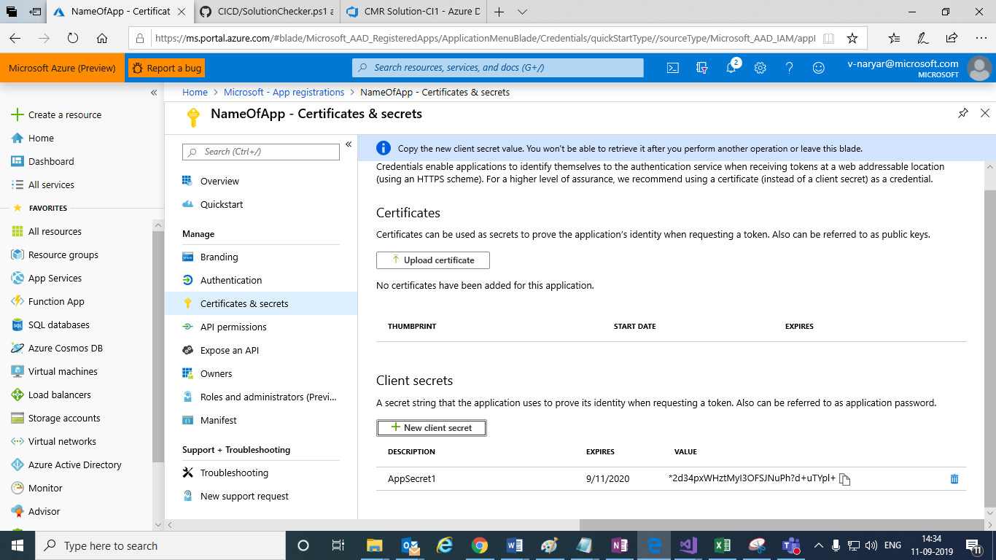

Copy above newly created App secret to clipboard

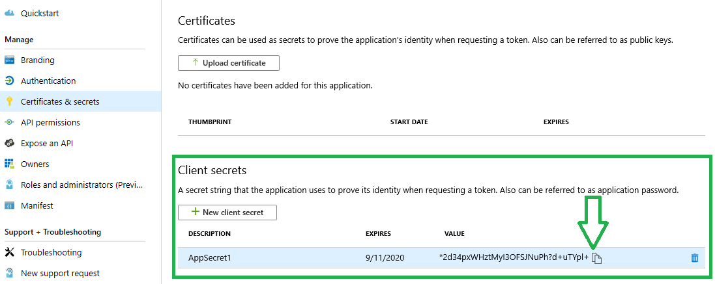

2. solution checker code in power shell script ,



Add above file in project in dynamic source control (Github or tfs) ,

And need to refer in the power shell task in the build pipeline in the devops build pipeline ,

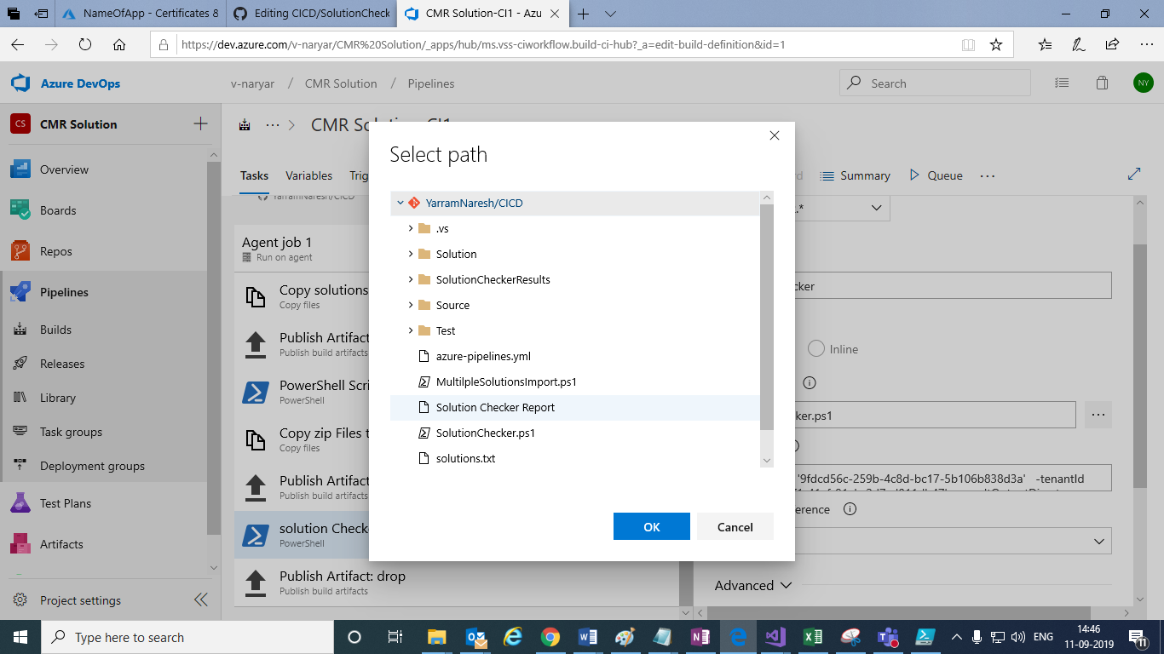

SolutionChecker.ps1 file should be selected ,

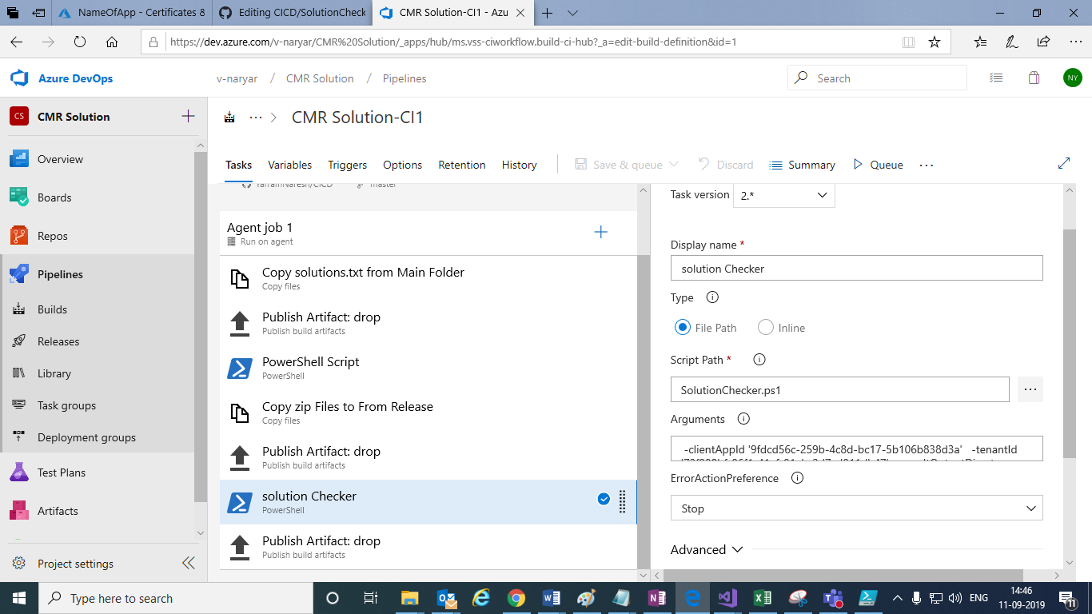

In the Arguments field: Add below script of params ,

-clientAppId '******-259b-4c8d-bc17-5b106b8*****'

-tenantId '*******-86f1-41af-91ab-*******'

-resultOutputDirectory '$(Build.ArtifactStagingDirectory)/SolutionContainer'

-ClientApplicationSecret '*****Hb_+N***qmW5YtoetftrLc280'

-rootPath '$(Build.ArtifactStagingDirectory)/SolutionContainer/'

Refer the below links to create App in Azure Active directory and add permissions of api

<https://nishantrana.me/2019/07/12/using-the-powerapps-checker-powershell-module-to-validate-the-solution/>

<https://docs.microsoft.com/en-us/powershell/module/microsoft.powerapps.checker.powershell/Invoke-PowerAppsChecker?view=pa-ps-latest>